CS614 – Data Warehousing

Assignment No.1 (Graded)

**Maximum Marks: 20**

**Instructions**

***Due Date: 29 April 2024***

The purpose of this assignment is to give you hands-on practice. It is expected that students will solve the assignment themselves. The following rules will apply during the evaluation of the assignment.

* Cheating from any source will result in zero marks in the assignment.
* The submitted assignment does NOT open or the file is corrupted.
* No assignment after the due date will be accepted
* Students can submit HTML, Images & Plain text only in this inline Mode. You may also insert an image file/table.
* DOC/pdf File uploading option will not be available) in inline assignment submission.

**Uploading Assignment Instruction**

Follow the given instructions to submit inline assignments.

* You can use MS Visio/ MS Paint for drawing the ERD Diagram etc.
* Students can insert the images of the following formats.



* Images and tables can be inserted using the following highlighted option in the interface.

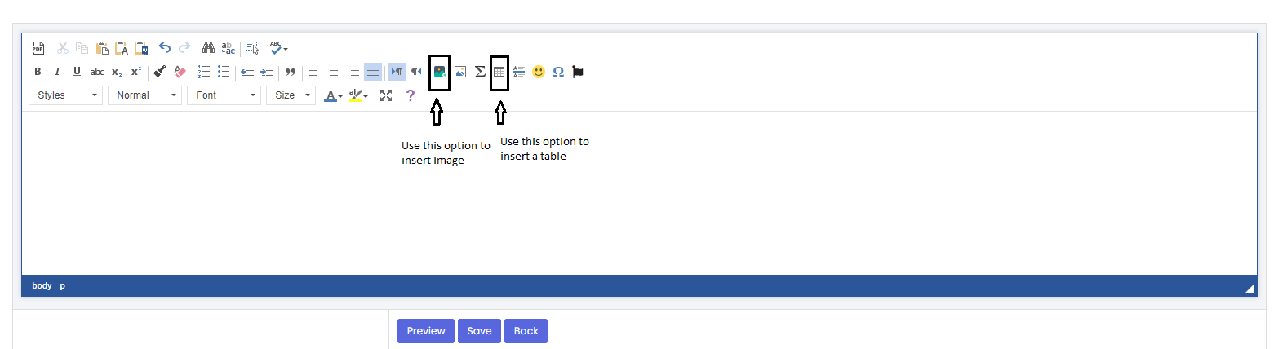

**Objective & Learning Outcome (Only 1 mention)**

After completing the assignment, the student will be able to apply Normalization and de-normalization techniques on database tables.

# Question No. 1 (Marks = 10)

c

Table 1: StaffBranch given below reflects a specific form of normalization.

**Table 1: StaffBranch**

|  |  |  |  |  |  |  |
| --- | --- | --- | --- | --- | --- | --- |
| StaffNo. | Name | position | Salary | BranchNo. | BranchAddress | TelNo. |
| S17005 | Rizwan Ahmed | Manager | 300000 | B001 | 7th – st. Al Anayat Co. G-11 Islamabad. | 302-3332-2 |
| S15002 | Arifa Javed | Assistant | 80000 | B001 | 7th – st. Al Anayat Co. G-11 Islamabad. | 302-3332-2 |
| S23361 | Ahmed Ali | Manager | 300000 | B002 | City Center Plaza, Karachi | 420-5847-5 |
| S40021 | Salman Ahmed | Assistant | 750000 | B002 | City Center Plaza, Karachi | 420-5847-5 |
| S00129 | Hafza Khan | Supervisor | 90000 | B003 | Naz Digital Plaza, Lahore. | 205-2584-3 |
| S01352 | Ameer Ali | Manager | 200000 | B004 | Yusif plaza Rawalpindi | 305-4561-9 |

You are required to identify the normalization form(NF) of the given table and also transform the given table into the 3rd normalization form (3NF) and provide the resultant tables.

**Note:** To convert in 3NF, first you need to convert it in 2NF, and resultant tables of 3NF are only required.

# Question No. 2 (Marks = 10)

Consider the following information about CUSTOMER and ORDER tables.

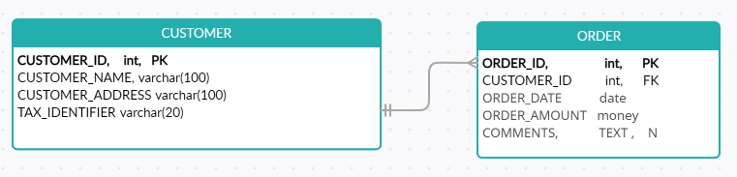

Figure 1: CUSTOMER_ORDER Relationship

**Table1 (Master):**

Header Size of the CUSTOMER table: = 60 Bytes

Number of records stored in CUSTOMER table: = 70000

**Table2 (Detail):**

Header size ORDER table: = 70 Bytes

Number of records stored in ORDER table: = 5000000

Suppose you have applied the pre-joining De-Normalization technique on the ‘CUSTOMER’ and ‘ORDER’ tables.

Calculate the size of the resultant table in Megabytes (MB), Gigabytes (GB), and Terabytes (TB). The reference column in these two tables is 8 bytes.

# Hint: There would be 5000000 records in the De-normalized table.

**Note: Plagiarism will be checked for each question. Please answer the questions in your own words and marks will be awarded based on your answer and plagiarism report.**

For any query about the assignment, contact at email [CS614@vu.edu.pk](mailto:CS614@vu.edu.pk)